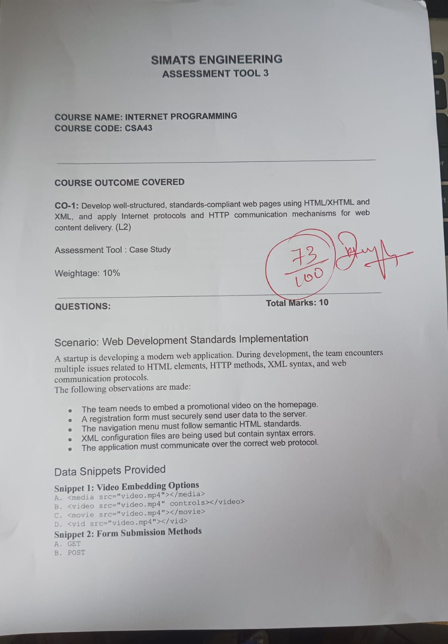

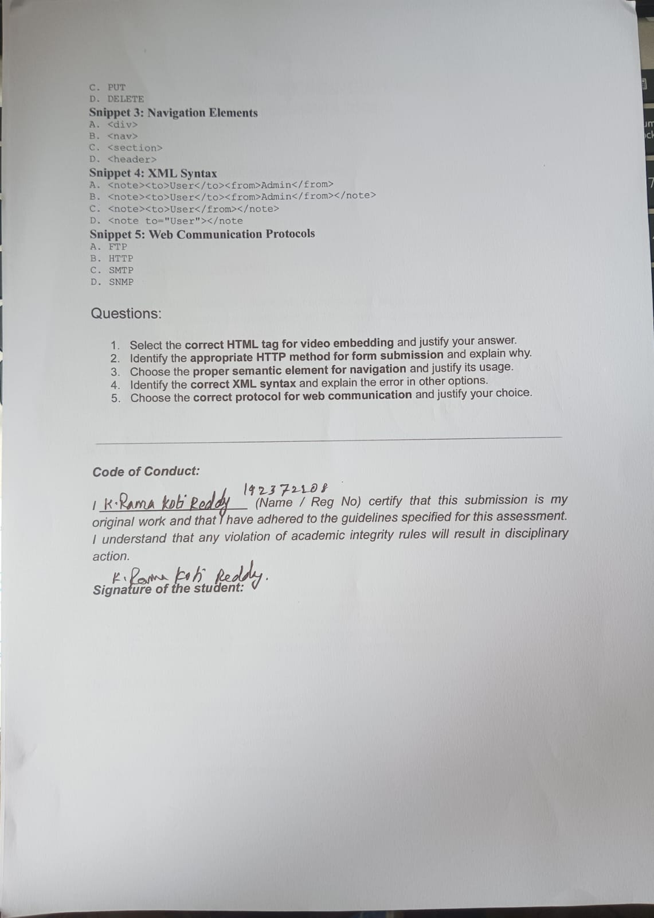

SIMATS ENGINEERING

ASSESSMENT TOOL 3

COURSE NAME: INTERNET PROGRAMMING COURSE CODE: CSA4308

NAME: K. RAMA KOTI REDDY

REGISTER NUMBER: 192372208

COURSE OUTCOME COVERED

CO-1: Develop well-structured, standards-compliant web pages using HTML/XHTML and XML, and apply Internet protocols and HTTP communication mechanisms for web content delivery. (L2)

Assessment Tool : Case Study

Weightage: 10%

QUESTIONS: Total Marks: 10

Scenario: Web Development Standards Implementation
A startup is developing a modern web application. During development, the team encounters multiple issues related to HTML elements, HTTP methods, XML syntax, and web communication protocols.
The following observations are made:

- The team needs to embed a promotional video on the homepage.
- A registration form must securely send user data to the server.
- The navigation menu must follow semantic HTML standards.
- XML configuration files are being used but contain syntax errors.
- The application must communicate over the correct web protocol.

Data Snippets Provided

Snippet 1: Video Embedding Options
- <media src="video.mp4"></media>
- <video src="video.mp4" controls></video>
- <movie src="video.mp4"></movie>

- <vid src="video.mp4"></vid>

Snippet 2: Form Submission Methods
- GET
- POST
- PUT
- DELETE

Snippet 3: Navigation Elements
- <div>
- <nav>
- <section>
- <header>

Snippet 4: XML Syntax
- <note><to>User</to><from>Admin</from>
- <note><to>User</to><from>Admin</from></note>
- <note><to>User</from></note>
- <note to="User"></note

Snippet 5: Web Communication Protocols
- FTP
- HTTP
- SMTP
- SNMP

Questions:

  - Select the correct HTML tag for video embedding and justify your answer.

Correct Answer: B
<video src="video.mp4" controls></video>
Justification:
- The <video> tag is the standard HTML5 element for embedding videos.
- The controls attribute provides play, pause, volume, and fullscreen controls.
- It is supported by all modern web browsers.

  - Identify the appropriate HTTP method for form submission and explain why.

Correct Answer: B. POST
Justification:
- The POST method sends form data in the HTTP request body.
- Sensitive information such as passwords is not visible in the URL.
- It is the recommended method for registration and login forms.

  - Choose the proper semantic element for navigation and justify its usage.

Correct Answer: B
<nav>
Justification:
- The <nav> element defines a navigation section in HTML5.
- It improves accessibility and SEO.
- It clearly identifies the navigation links of the webpage.

  - Identify the correct XML syntax and explain the error in other options.

Correct Answer: B
<note>
<to>User</to>
<from>Admin</from>
</note>

Errors in Other Options
Option A
<note><to>User</to><from>Admin</from>
- Missing the closing </note> tag.

Option C
<note><to>User</from></note>
  - The opening tag <to> is incorrectly closed with </from>.
  - XML requires matching opening and closing tags.

Option D
<note to="User"></note
  - The closing > is missing from the </note> tag.
  - The XML document is incomplete and not well-formed.

  - Choose the correct protocol for web communication and justify your choice.

Correct Answer: B. HTTP
Justification:
  - HTTP (HyperText Transfer Protocol) is the standard protocol used for communication between web browsers and web servers.
  - It is responsible for requesting and delivering web pages and other web resources.
  - Secure communication is achieved using HTTPS, which encrypts HTTP traffic.

Why the Other Options Are Incorrect
  - FTP – Used for transferring files.
  - SMTP – Used for sending email.
  - SNMP – Used for monitoring and managing network devices.

OUTPUT:

